AI Exposure and Labor Market Implications in Bangladesh

Objective and Methodology
This analysis examines how occupational exposure to generative artificial intelligence (AI)—proxied by the AI Occupational Exposure Estimate (AIOE)—maps onto the structure of Bangladesh’s labor market, using data from the 2022 Labor Force Survey (LFS).
To operationalize this, AIOE scores—originally developed under the U.S. SOC-10 classification—were crosswalked to ISCO-08 codes using an official concordance. These scores were merged with LFS microdata at the 4-digit ISCO level and aggregated across key labor market dimensions: occupation (ISCO-1 digit), education level, and urban/rural location. The analysis focuses specifically on exposure to large language models (LLMs), which reflect the susceptibility of occupational tasks to automation through generative AI.
Important caveats:
- AIOE coverage is incomplete for several low-skill and informal occupations, including subsistence agriculture and elementary labor (ISCO-6 and ISCO-9), leading to underrepresentation of these segments.
- Negative AIOE scores indicate occupations considered resistant to AI substitution—typically those involving manual or non-routine work.
- Missing values in education and ISCO-1 classifications further limit full population coverage.

Key Findings

1. AI Exposure by Occupation (ISCO-1 digit)
ISCO-1 Group | AIOE Score
Professionals (2) | 1.13
Managers (1) | 0.88
Clerical Support (4) | 0.77
Agricultural Workers (6) | −0.85
Elementary Occupations (9) | −1.18
Interpretation:
Professionals, managers, and clerks exhibit high exposure, due to the cognitive and communicative nature of their tasks. These are occupations where LLMs can complement or replace human input. By contrast, agricultural and elementary occupations are strongly AI-resistant, reflecting the limited applicability of LLMs to physical, manual, or unstructured work.

2. AI Exposure by Education Level
Education Group | AIOE Score
Post-secondary | 0.62
Secondary | −0.02
Primary | −0.55
No formal education | −0.72
Interpretation:
AI exposure increases with education. Only post-secondary workers exhibit positive average exposure, aligning with their higher likelihood of working in service-sector or professional roles. Workers without formal education are concentrated in occupations that are less susceptible to AI automation.

3. AI Exposure by Urban/Rural Location
Location | AIOE Score
Urban | −0.13
Rural | −0.47
Interpretation:
Urban workers are modestly more exposed to AI, reflecting the higher prevalence of formal employment and cognitive-intensive occupations in cities. However, both urban and rural averages remain negative, underscoring that LLM-relevant tasks represent a small share of Bangladesh’s labor market overall.

4. AI Exposure and Wages

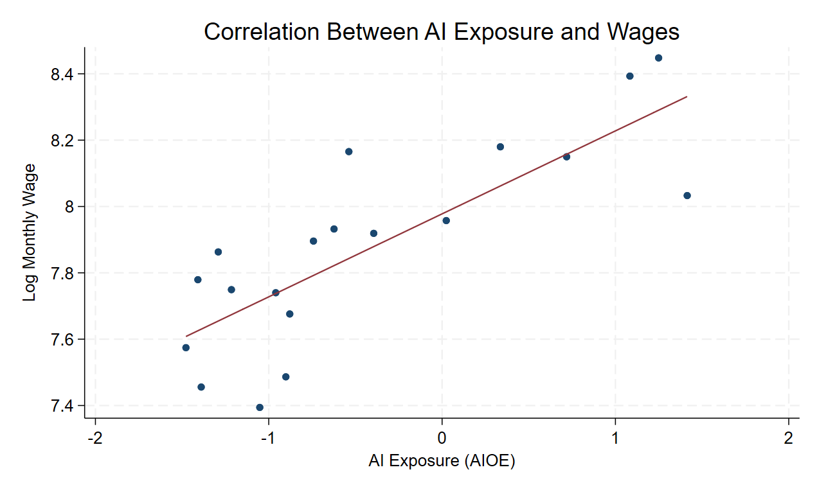
A binned scatterplot reveals a positive correlation between AIOE and log monthly wages. As AIOE scores increase from approximately −1 to +2, log wages increase from ~7.4 to 8.4.
Interpretation:
This relationship suggests that AI-exposed occupations tend to be higher paid, likely due to their skill intensity. However, some negative-AIOE occupations also command moderate wages, implying that AI resistance does not necessarily equate to low labor market value.

Interpretation and Policy Implications
The analysis reveals a structurally segmented AI exposure landscape in Bangladesh. High-skilled, urban, and more educated workers are more likely to face transformation through generative AI. However, exposure remains modest in absolute terms and heavily concentrated in select occupations.
Key insights:
- Occupational divide: AI exposure is highest among professionals, managers, and clerical workers (ISCO-1, 2, 4), while agricultural and elementary workers (ISCO-6, 9) remain largely unaffected.
- Education gradient: Post-secondary educated workers are most exposed, reflecting their participation in digital- and information-centric roles.
- Urban–rural gap: Urban workers are more likely to be exposed, but AI-relevant work remains limited overall.
- Wage alignment: AIOE scores correlate with higher wages, consistent with AI’s alignment with higher-skill labor—but not exclusively.

Policy Recommendations
- Monitor task evolution in high-exposure roles
Track occupational changes among managers, professionals, and clerks to identify early signals of automation risk or task reallocation.
- Invest in cognitive and digital skills
Equip post-secondary and tertiary graduates with capabilities that complement AI, including critical thinking, data literacy, and ethical AI understanding.
- Support inclusive AI adoption
Avoid concentration of AI benefits among high-income, formal-sector workers. Extend digital tools and training to middle-skill occupations and informal enterprises.
- Tailor rural strategies
In agriculture and rural economies, AI exposure remains negligible. Prioritize investments in mechanization, connectivity, and productivity-enhancing technologies not reliant on LLMs.

